for official use only (FOUO) iNFORMATION

What is it?

Inspection reports

Investigation documents

DSS budgetary information

Contractual bids with DSS

Personnel information
How should I safeguard it?
- Locked cabinets
- Key or cipher locked rooms
- Locked outer office doors
- Guarded building
- Alarm
- Locked cabinet

Personnel Security Criteria
- DoD 5200.2R - Personnel Security Programs
- DSS Regulation 25-3

Physical Security Issues
- DoD 5200.8R
- DSS Regulation 25-11
- http://infolink.dss.mil/organizations/security

If you have any questions, or at any time you are unsure of what you can or can not do, always check with the DSS Security Office.
703-325-9458

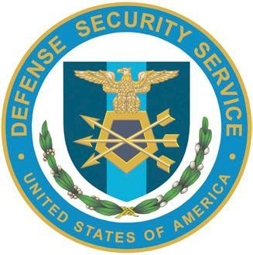

DEFENSE SECURITY SERVICES
sECURITY AWARENESS Refresher

DoDM 5200.01 vol 1-4
“Information Security Program”
http://www.cdse.edu/index.html
National Industrial Security Program Operating Manual (NISPOM)

need to know?
Need-to-know is a determination made by the possessor of classified information that a prospective recipient has a requirement for access to, knowledge of, or possession of the classified information to perform tasks or services essential to the fulfillment of a classified contract or program.

classified information
- CONFIDENTIAL SF 705
- SECRET SF 704
- TOP SECRET SF 703

WHAT’S CLASSIFIED?
@ Apparatus A Models
ù Devices ¸ Photographs
¨ Documents ¹ Recordings
 Letters  Reproductions
t Machinery ¥ Sketches
þ Maps and Charts  Products

There is NO statute of limitations regarding the unauthorized disclosure of classified information

classified

HOW DO i SAFEGUARD?
CONFIDENTIAL & SECRET material must be stored in a GSA-approved container.
TOP SECRET information must be stored in GSA-approved containers in an alarmed area.
Classified Information MUST
- Never be left unattended.
- Never be discussed in public places.
- Never be processed on your computer unless approved

Classified Information MUST
- Be discussed on secure telephones
- Be under the control of an authorized person and
- Be stored in approved storage containers

Remember you must always protect our nation’s secrets. You are the front line of defense.

EMPLOyee Identification Process

Common Access Card (CAC)

Standardized DoD-wide form of identification

Used by civilians, contractors, & military personnel

Contains protected personal identifying data

Contains Public Key Infrastructure (PKI) certificate set

Used for e-mail encryption, digital signing, network & application access

